**Model output**

Family: zero_one_inflated_beta

Links: mu = logit; phi = identity; zoi = identity; coi = identity

Formula: Jtu ~ scaleacc_100 + scalehpd_100 + duration_plot + TAXA + (1 | STUDY_ID)

Data: data1 (Number of observations: 5787)

Samples: 4 chains, each with iter = 4000; warmup = 1000; thin = 1;

total post-warmup samples = 12000

Group-Level Effects:

~STUDY_ID (Number of levels: 91)

Estimate Est.Error l-95% CI u-95% CI Rhat Bulk_ESS Tail_ESS

sd(Intercept) 0.67 0.07 0.55 0.83 1.00 2081 3894

Population-Level Effects:

Estimate Est.Error l-95% CI u-95% CI Rhat

Intercept -0.05 0.36 -0.76 0.66 1.00 3014 5866

scaleacc_100 -1.05 0.27 -1.59 -0.51 1.00 5703 7474

scalehpd_100 -0.17 0.11 -0.38 0.04 1.00 14624 9463

duration_plot 0.02 0.00 0.01 0.02 1.00 13847 10892

TAXAMammals 0.78 0.34 0.11 1.45 1.00 1925 3266

TAXATerrestrialinvertebrates 1.02 0.34 0.35 1.69 1.00 1738 3652

TAXATerrestrialplants 0.03 0.27 -0.48 0.55 1.00 1409 2987

Family Specific Parameters:

Estimate Est.Error l-95% CI u-95% CI Rhat Bulk_ESS Tail_ESS

phi 13.15 0.32 12.54 13.77 1.00 15377 9349

zoi 0.43 0.01 0.42 0.45 1.00 18031 8471

coi 0.16 0.01 0.14 0.17 1.00 18058 8944

Samples were drawn using sampling(NUTS). For each parameter, Eff.Sample

is a crude measure of effective sample size, and Rhat is the potential

scale reduction factor on split chains (at convergence, Rhat = 1).

**Research questions and their results**

1. Do sites with higher accessibility to cities experience more changes in assemblage composition over time (temporal turnover) than locations with lower accessibility?
   1. How does the duration of ecological monitoring influence the magnitude of detected temporal turnover trends?

Contrary to my predictions, I found that temporal turnover has decreased as accessibility is increasing across the 5787 time-series surveyed (slope = -1.05, CI = -1.59 to -0.51, Figure 1, see Table 1 for more model outputs). On average, for every 10% increase in accessibility, turnover decreases by 4%.

In line with my predictions, the duration of the observation influenced the magnitude of the detected temporal turnover trends, with higher turnover increases for longer observations of sites.

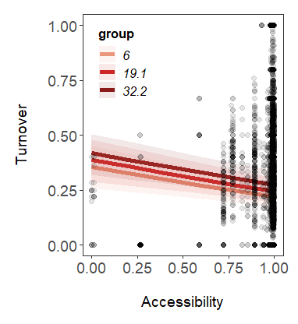

1. How does temporal turnover of ecological communities respond to levels of accessibility across taxa (birds, mammals, terrestrial invertebrates, terrestrial plants)?

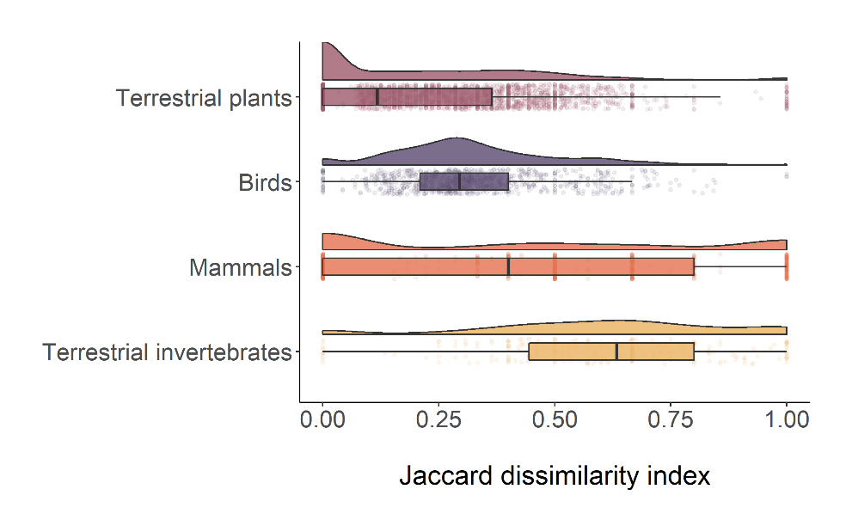

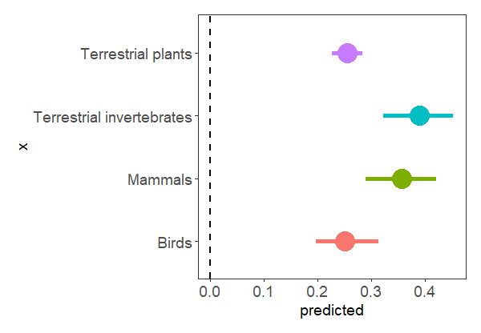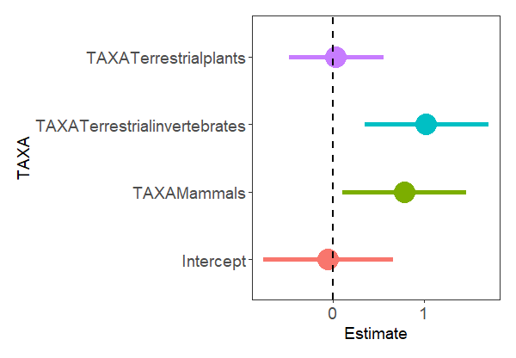  
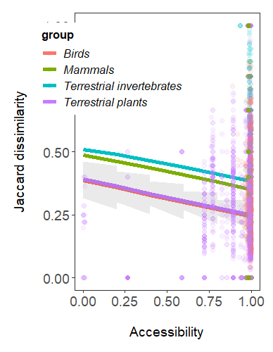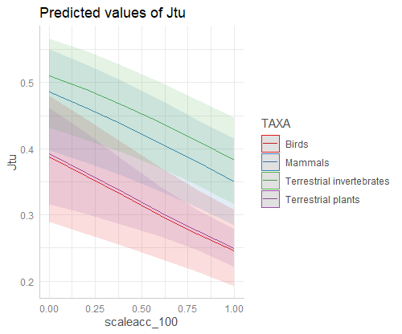

1. How is temporal turnover influenced by an interaction between human population density and accessibility?

Facet: low, middle, high human population density (quantiles)

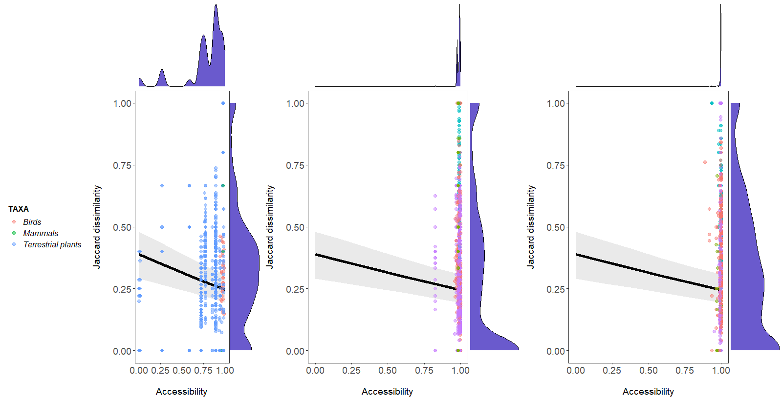

Facet: low, middle, high human population density (values)

